SUPPLEMENTARY MATERIAL

Supplementary Methods
Database generation: data processing and NLP model
The NLP pipeline includes a language detector, sentence detector, text tokenizer, clinical entity recognizer, entity linker, and attribute extractor. Models were trained on extensive medical data and fine-tuned for this specific study. The NLP model coded clinically relevant information from patients' EHRs using machine learning. Trained models detected concepts from the specified datapoint list in the EHRs. The output is a text string representing a clinically meaningful entity, each assigned a UMLS code (CUI; see Supplementary Table 1). The Observational Medical Outcomes Partnership Common Data Model (OMOP CDM) serves as the clinical data warehouse (i.e., database), with data point CUIs transformed into AthenaIDs according to the warehouse standards [6, 16]. The OMOP Athena hierarchies capture descendants under datapoints, utilizing the hierarchical relationships of the OMOP CDM.

Validation
The four validation steps were as follows: (1) At data intake, the data sources that were ingested to populate the OMOP database were discussed with the partaking hospitals to ensure coverage of all datapoints, and were verified regarding whether all expected data sources were delivered, all required columns within those sources were complete (including missing value checks), and whether date ranges and patient selection were consistent and compliant. (2) As previously described [1, 15], performance of the NLP model was assessed as to whether the extracted concepts were correct (precision) and whether the expected number of concepts were extracted from the documents (recall). Both recall and precision checks compare the model results to the gold standard generated by human annotators. The harmonic mean of precision and recall yields the F1 score. (3) During clinical validation of individual datapoints, physicians validated the precision by performing a source analysis overview of data from their own hospital regarding each datapoint, the underlying CUI, the number of unique patients for which the clinical concept was detected, and whether it was obtained from a structured or unstructured data source. (4) During clinical validation of aggregated reports, physicians performed a “sanity check” of statistics, to identify potentially missing data sources or correct the data dictionary.

Statistical analysis
In order to create oncology treatment regimens (i.e., antineoplastic agents used simultaneously), scripts were created based on the OncoRegimenFinder (OncologyWG/OncoRegimenFinder/readme.md at master · OHDSI/OncologyWG · GitHub). First, all drug administrations that are antineoplastic agents were identified. When there was a date difference less than 30 days between the administration of different antineoplastic agents, they were collapsed together into a regimen. Implausible regimens for a specific indication were filtered out, which can occur when a patient has multiple tumors.

Supplementary Figures

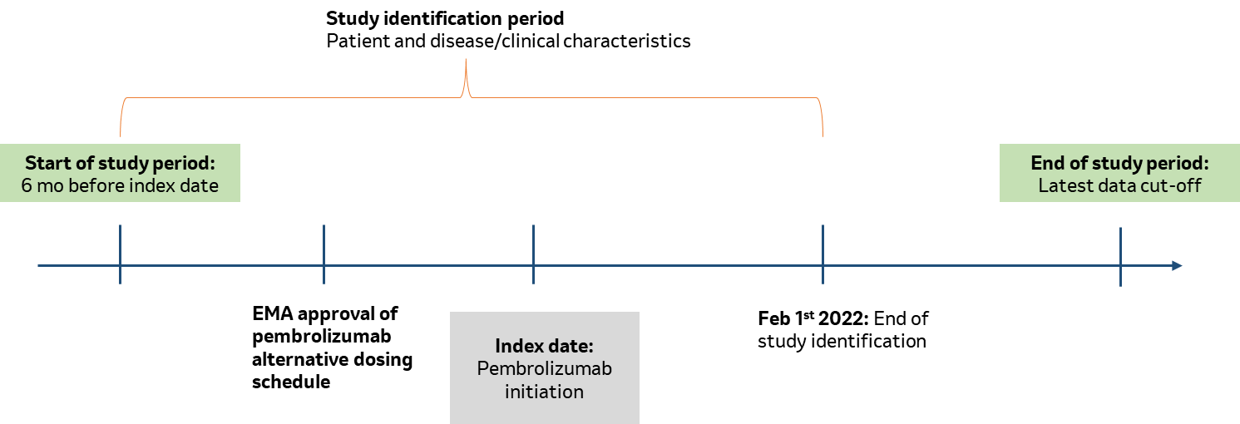

Supplementary Figure 1. Study timeline. The study period began 6 months before the first detected index date (“pre-index period”) and ended at data cut-off. The 6-month pre-index period was used to detect a prior exposure to anti-PD1/PD-L1 therapy, which was an exclusion criterion.

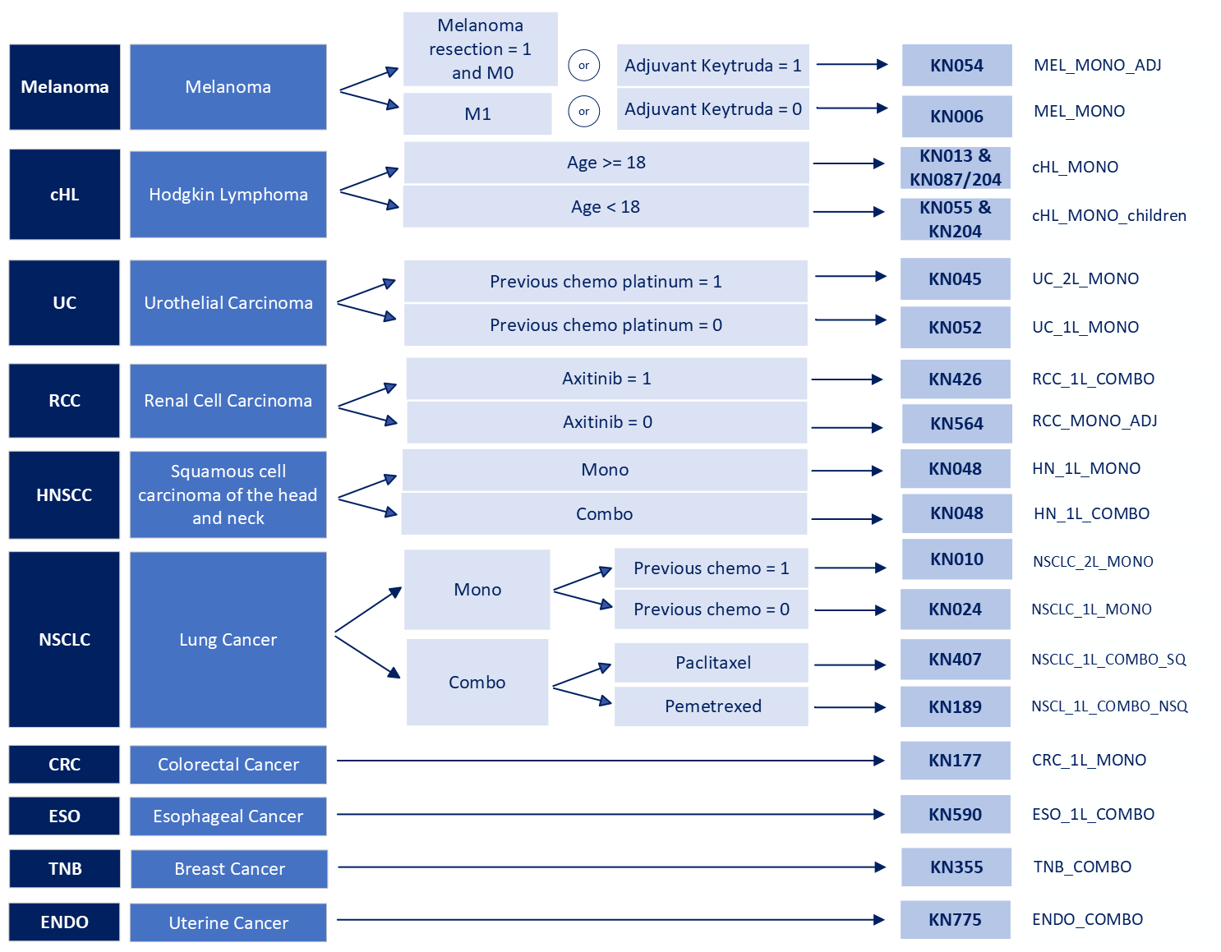
Supplementary Figure 2. Indication split logic for patient categorization into tumor type, treatment line, pembrolizumab monotherapy vs combination therapy, histology (lung cancer), and treatment setting (RCC, melanoma). ADJ: adjuvant; cHL: classic Hodgkin lymphoma; COMBO: pembrolizumab combination therapy; CRC: colorectal cancer; ENDO: endometrial cancer; ESO: esophageal cancer; HNSCC: squamous cell carcinoma of the head and neck; KN: KEYNOTE pembrolizumab clinical trial; MONO: pembrolizumab monotherapy; NSCLC: non-small cell lung carcinoma; NSQ: non-squamous; RCC: renal cell carcinoma; SQ: squamous; TNB: triple-negative breast cancer; UC: urothelial carcinoma.

Supplementary Tables

Supplementary Table 1. Indications approved by EMA and reimbursed in Belgium as of 01 February 2022
Monotherapy Indications
Melanoma: advanced (unresectable or metastatic)
Melanoma: adjuvant treatment of adults with Stage III melanoma and lymph node involvement who have undergone complete resection
Non-small cell lung carcinoma: first-line treatment of metastatic NSCLC in adults whose tumors express PD-L1 with a ≥ 50% tumor proportion score (TPS) with no EGFR or ALK positive tumor mutations
Non-small cell lung carcinoma: locally advanced or metastatic whose tumors express PD-L1 with a ≥ 1% TPS and who have received at least one prior chemotherapy regimen
Classical Hodgkin lymphoma: relapsed or refractory classical Hodgkin lymphoma who have failed autologous stem cell transplant (ASCT) or following at least two prior therapies when ASCT is not a treatment option
Urothelial carcinoma: locally advanced or metastatic who have received prior platinum-containing chemotherapy
Urothelial carcinoma: locally advanced or metastatic who are not eligible for cisplatin-containing chemotherapy and whose tumors express PD-L1 with a combined positive score (CPS) ≥ 10
Head and neck squamous cell carcinoma: first-line treatment of metastatic or unresectable recurrent head and neck squamous cell carcinoma in adults whose tumors express PD-L1 with a CPS ≥ 1
Colorectal cancer: first-line treatment of metastatic microsatellite instability-high (MSI-H) or mismatch repair deficient (dMMR)
Combination indications
Non-small cell lung carcinoma: first-line treatment of metastatic non-squamous NSCLC in adults whose tumors have no EGFR or ALK positive mutations
Non-small cell lung carcinoma: first-line treatment of metastatic squamous NSCLC
Renal cell carcinoma: first-line treatment of advanced RCC in adults
Head and neck squamous cell carcinoma: first-line treatment of metastatic or unresectable recurrent head and neck squamous cell carcinoma in adults whose tumors express PD-L1 with a CPS ≥ 1
Esophageal cancer: First-line treatment of locally advanced unresectable or metastatic carcinoma of the esophagus or HER-2 negative gastroesophageal junction adenocarcinoma, in adults whose tumors express PD-L1 with a CPS ≥ 10
Triple-negative breast cancer: locally recurrent unresectable or metastatic TNBC in adults whose tumors express PD-L1 with a CPS ≥ 10 and who have not received prior chemotherapy for metastatic disease
Endometrial carcinoma: advanced or recurrent who have disease progression on or following prior treatment with a platinum-containing therapy in any setting and who are not candidates for curative surgery or radiation

Supplementary Table 2. Date ranges per data source reflecting overall pre- and post-observation times. Pre- and post-observation times varied per hospital and per data source, with an overall range from February 1998 to January 2023 (Table 1). In the case of dossiers, medical history described in the text (e.g., comorbidities) could refer to dates further in the past than the dates of the dossiers themselves.

DATA SOURCE: | Minimum Data Set (“MZG” in Dutch) | Cancer registry | Medication (structured data) | Dossiers (unstructured data)
DATES: | January 2016- June 2022 | February 1998- June 2022 | January 2004- January 2023 | October 2006- November 2022

Supplementary Table 3. Full data point list
Datapoint | CUI
Atezolizumab (Tecentriq) | C4055433
Auto-immune disease | C0004364
Avelumab (Bavencio) | C4055417
Breast cancer | C0678222, C0006142
Cancer stage | C0804690, C0804696, C0027646, C1300486
Cardiovascular disease | C0007222
Cemiplimab (Libtayo) | C4724806
Colorectal carcinoma | C4722085, C0009402
COPD | C0024117
Diabetes mellitus | C0011849, C0011847
Dostarlimab (Jemperli) | C5242455
Durvalumab (Imfinzi) | C4473954, C4055109
ECOG performance status | C1520224, C1828127
Endometrial cancer | C0014170
Esophageal carcinoma | C0152018, C0346619
Head and neck cancer | C0278996
Lung cancer | C0242379
Melanoma | C0025202, C0346040
Metastatic neoplasm | C2939419, C2939420
Metastatic stage (M) | C0456533
Nivolumab (Opdivo) | C3657270
Non-squamous non-small cell lung cancer | C2585890
Pembrolizumab (Pembrolizumab) | C3658706, C3855203
Renal cell carcinoma | C1266044, C0279702, C0007134
Squamous non-small cell lung cancer | C0149782, C4509816
Tobacco smoking status | C0453996
Transitional cell carcinoma of bladder | C0279680
Transitional cell carcinoma of kidney | C1319314
Transitional cell carcinoma of ureter | C0577692
Urothelial carcinoma | C0279680, C0007138, C4288754
WHO performance status | C1298651
Karnofsky Performance Status | C0206065

Supplementary Table 4. Data dictionary
Variable | Datapoint | Objective | Calculation logic | Source
Pembrolizumab start date (index event) | Pembrolizumab (Pembrolizumab) | Inclusion/ exclusion criteria (I/E) | The start date of Pembrolizumab (index event) was calculated as the first administration. The difference between consecutive administrations was calculated. When the difference between two administrations was larger than 120 days, the patient was considered to have restarted the treatment (i.e., rechallenge). | Structured data source
Age at index | / | I/E | Calculated as the difference in years between index event date (Pembrolizumab start date) and patient’s date of birth (OMOP person table) | Structured data source
Prior exposure to anti-PD1/PD-L1 | Pembrolizumab (Pembrolizumab) | I/E | A patient was considered to have had prior exposure to anti-PD1/PD-L1 treatment when at least 1 administration of at least one of the listed datapoints in the pre-index period (6 months prior to index event) was present. | Structured data source
Prior exposure to anti-PD1/PD-L1 | Atezolizumab (Tecentriq) | I/E |  | Structured data source
Prior exposure to anti-PD1/PD-L1 | Avelumab (Bavencio) | I/E |  | Structured data source
Prior exposure to anti-PD1/PD-L1 | Cemiplimab (Libtayo) | I/E |  | Structured data source
Prior exposure to anti-PD1/PD-L1 | Durvalumab (Imfinzi) | I/E |  | Structured data source
Prior exposure to anti-PD1/PD-L1 | Nivolumab (Opdivo) | I/E |  | Structured data source
Prior exposure to anti-PD1/PD-L1 | Dostarlimab (Jemperli) | I/E |  | Structured data source
Pembrolizumab initiation dose | Pembrolizumab (Pembrolizumab) | Cohort generation (CG) | The dose (in mg) that was administered to the patient at the start date of Pembrolizumab treatment | Structured data source
Level 1 cohort split | Pembrolizumab initiation dose | CG | A patient was considered a SD initiator when the Pembrolizumab initiation dose was 200 mg or lower.  A patient was considered an ED initiator when the Pembrolizumab initiation dose was higher than 200 mg | Structured data source
Difference lag quantity | Pembrolizumab (Pembrolizumab) | CG | The difference in mg between consecutive Pembrolizumab administrations of a patient. | Structured data source
Type switch | Difference lag quantity | CG | SD-to-ED dosing scheme when the difference lag quantity was 200 mg  ED-to-SD dosing scheme when the difference lag quantity was -200 mg  If none of the above were detected, the patient was considered not to have switched their medication dosing scheme. | Structured data source
Level 2 cohort split | Level 1 cohort split | CG | SD only cohort: when the patient was a SD initiator and had no switches  ED only cohort: when the patient was an ED initiator and had no switches  SD-to-ED and stay cohort: when the patient was a SD initiator and had only one type of switch (SD-to-ED)  SD initiator with more than 1 switch: when the patient was a SD initiator and had a SD-to-ES switch and then an ED-to-SD switch | Structured data source
Level 2 cohort split | Type switch | CG |  | Structured data source
Age at index | / | Primary objective (PO) | Calculated as the difference in years between index event date (Pembrolizumab start date) and patient’s date of birth (OMOP person table) | Structured data source
Gender | / | PO | Obtained from the gender concept ID in the OMOP person table | Structured data source
Smoking status closest before Pembrolizumab start | Tobacco smoking status | PO | Closest value prior to index event was split in ‘Non-smoker’, ‘Smoker’, ‘Ex-smoker’, ‘Smoking status unknown’ depending on source value. | Structured data source and NLP
Stage closest before Pembrolizumab start (IV/ non-IV) | Cancer stage | PO | The closest stage before index event and the first metastatic neoplasm (excluding lymph node metastases) and the first date that the metastatic stage was 1 were retrieved from structured and NLP sources. First, the structured sources were considered: If the patient had a stage IV (including substages) or the patient had a record of metastatic neoplasm or of metastatic stage that equaled 1 (before the index event), the patient was assigned to the “stage IV” group. If the stage was not stage IV and not blank (unknown), the patient got assigned to the ”stage non-IV” group. If no categorizing could be done based on structured data, the NLP data was considered and categorized in the same manner. | Structured data source and NLP
Stage closest before Pembrolizumab start (IV/ non-IV) | Metastatic stage | PO |  | Structured data source and NLP
Stage closest before Pembrolizumab start (IV/ non-IV) | Metastatic neoplasm | PO |  | Structured data source and NLP
Histology closest before Pembrolizumab start (for lung cancer patients) | Non-squamous non-small cell lung cancer (NSCLC) | PO | The histology type (squamous vs non-squamous) present closest before index event was retrieved. Categorization was performed into different groups: (1) squamous NSCLC (2) non-squamous NSCLC, or (3) other or unknown. | Structured data source and NLP
 | Squamous non-small cell lung cancer (NSCLC) | PO |  | Structured data source and NLP
Comorbid condition - Diabetes | Diabetes mellitus | PO | When the first record of the datapoint was present before the index event, it was considered a comorbid condition. Gestational Diabetes was excluded as it is a transient condition. | Structured data source and NLP
Comorbid condition – Cardiac-CVD | Cardiovascular disease | PO | When the first mention of the datapoint was present before the index event, it was considered a comorbid condition. Following conditions under the hierarchy were excluded as being a cardiovascular comorbidity: “Hypotension” and “Varicose veins of lower extremity”. | Structured data source
Comorbid condition – COPD | COPD | PO | When the first mention of the datapoint was present before the index event, it was considered a comorbid condition. When the term “emphysema” was detected by NLP, it was not considered as COPD to avoid false positives resulting from radiology reports. | Structured data source and NLP
Comorbid condition – Auto-immune diseases | Auto-immune disease | PO | When the first mention of the datapoint was present before the index event, it was considered a comorbid condition. | Structured data source and NLP
Performance status closest before Pembrolizumab start | ECOG performance status finding | PO | The latest performance status value (ECOG, WHO or Karnosfky) prior to the index event was retrieved for each patient, with a time limit of 6 months before the index event. For WHO and ECOG scores of 0 where classified as 0, scores of 1 as 1 and scores equal or higher than 2 as 2+. When the score was ambiguous (e.g., WHO- score 1-2), the lowest value was consistently taken. For Karnosfky, when the score was 100 the performance status was 0, when the score was between 80 and 90 the performance status was classified as 1. Scores equal to or lower than 70 were classified as 2+. | NLP
Performance status closest before Pembrolizumab start | WHO performance status | PO |  | NLP
Performance status closest before Pembrolizumab start | Karnofsky Performance Status | PO |  | NLP
Tumor type | Indication | PO | Deduced from the indication (see Figure 1) | Indications were created based on both structured and NLP data
Treatment type | Indication | PO | Deduced from the indication (see Figure 1)
Line of therapy | Indication | PO | 1L when indication contains ‘1L’ , 2L when indications contains ‘2L’ (see Figure 1), otherwise blank
Date of initial diagnosis | Lung cancer | PO | The first mention of the tumor type matching the indication was retrieved from the structured data of the hospital, which is used for reporting to the National cancer registry. | Structured data source
Date of initial diagnosis | Melanoma | PO |  | Structured data source
Date of initial diagnosis | Classical Hodgkin lymphoma | PO |  | Structured data source
Date of initial diagnosis | Urothelial carcinoma | PO |  | Structured data source
Date of initial diagnosis | Transitional cell carcinoma of ureter | PO |  | Structured data source
Date of initial diagnosis | Transitional cell carcinoma of kidney | PO |  | Structured data source
Date of initial diagnosis | Transitional cell carcinoma of bladder | PO |  | Structured data source
Date of initial diagnosis | Primary malignant neoplasm of bladder | PO |  | Structured data source
Date of initial diagnosis | Renal cell carcinoma | PO |  | Structured data source
Date of initial diagnosis | Head and neck cancer | PO |  | Structured data source
Date of initial diagnosis | Colorectal carcinoma | PO |  | Structured data source
Date of initial diagnosis | Esophageal carcinoma | PO |  | Structured data source
Date of initial diagnosis | Malignant neoplasm of gastroesophageal junction | PO |  | Structured data source
Date of initial diagnosis | Breast cancer | PO |  | Structured data source
Date of initial diagnosis | Endometrial cancer | PO |  | Structured data source
Time between initial diagnosis and Pembrolizumab treatment start | Date of initial diagnosis | PO | Time between date of initial diagnosis and Pembrolizumab start date (in days) | Structured data source
 | Pembrolizumab start date | PO |  | Structured data source

Supplementary Table 5. Pembrolizumab dosing schedules according to COVID-19-related time periods.
 | SD only  (% of SD initiators) | ED only  (% of ED initiators) | SD to ED  and stay  (% of SD initiators) | Start SD more than 1 switch  (% of SD initiators)
Pre-COVID-19 period, n (%) | 44 (85) | 6 (100)​ | 5 (10) | <5​
COVID-19 period, n (%) | 102 (89)​ | 11 (100) | 11 (10) | <5​
SD initiators pre-COVID-19: 52 patients; SD initiators COVID-19: 115 patients; ED initiators pre-COVID-19: 6 patients; ED initiators COVID-19: 11 patients.

